The EU: A climate leader, but headed in the wrong direction
By Indur M. Goklany

It is claimed that the EU has been a global leader in climate change mitigation. [“Mitigation” is climate change jargon for reducing the impacts of climate change by reducing greenhouse gas emissions or concentrations whereas “adaptation” would address climate change by reducing its negative impacts or taking advantage of its positive impacts.]
The EU has indeed been very vocal on pushing mitigation, As of 2006, the EU-15 had only gone one-third of the way toward meeting its Kyoto target of reducing its GHG emissions by 8 percent below the 1990 baseline in 2008-12 (according to the European Environment Agency). But this represents no progress since the signing of the Kyoto Protocol in 1997: the EU-15’s emissions were unchanged between 1997 and 2006. The greater problem, however, is that even if all the Protocol’s signatories (including the US, which signed but didn’t ratify) meet the Protocol’s targets, it would reduce climate change only marginally — by less than 7% in 2100 — while costing around $165 billion annually.
Undaunted by its failure to deliver, or the futility of the Kyoto Protocol, the European Union upped its rhetoric on mitigation. At the December 2007 climate change negotiations in Bali, the EU was for a 25-40% reduction in GHG emissions from 1990 levels in 2020, and a 50% reduction in 2050 (also from 1990 levels). Currently it’s apparently in favor of a 20% reduction in 2020 which it would increase to 30%, if others also join. The EU also favors limiting climate change to 2°C above the pre-industrial level.
While all this chest pounding burnishes the EU’s green credentials, none of these targets are justified by any analysis. Climate change economist Richard Tol, a supporter of mitigation, who holds joint positions at Hamburg University, Amsterdam’s Vrije University, and Carnegie Mellon University, notes in a peer reviewed paper (available at http://dx.doi.org/doi:10.1016/j.enpol.2005.12.003), “[The 2°C] target is supported by rather thin arguments, based on inadequate methods, sloppy reasoning, and selective citation from a very narrow set of studies… Overall, the 2°C target of the EU seems unfounded.”
Each of the above mitigation targets, moreover, fails the benefit-cost test.
Yale economist, William Nordhaus, the dean of climate change economics, estimates that a 2°C target would cost $11.3 trillion while delivering only $9.5 trillion in benefits. That is, it would impose a net cost on humanity of $1.8 trillion. This, despite a tendency to substantially overestimate the damages from climate change (and, therefore, the benefits of mitigation), because the impacts analyses that he relies upon don’t fully account for future increases in adaptive capacity that should occur if one gives any credence to the high rates of economic growth that drive much of the IPCC’s estimates of future climate change. Moreover, secular technological change — generally ignored in impacts analyses — should further enhance adaptive capacity. Together, such increases in adaptive capacity accumulated over decades should substantially reduce the negative impacts of climate change (see “Is a Richer-but-warmer World Better than Poorer-but-cooler Worlds?”)
Nordhaus also estimates that the optimum mitigation pathway consists of a 15% reduction in greenhouse gas emissions during the 2010-2019 period, 25% reduction by 2050, and 45% reduction by 2100. This pathway requires much more modest reductions than the above pathways favored by the EU.
In addition to advocating mitigation targets that are neither justified by any science nor meet the cost-benefit test, the EU has embarked on policies that are counterproductive. First, its policies designed to displace fossil fuels with biofuels in order to mitigate greenhouse gas emissions and slow global warming, in conjunction with similar policies in the US, have helped raise food prices worldwide at a time when demand has also escalated due to increasingly affluent populations in China, India and other developing countries. According to the UN Food and Agricultural Organization, biofuel production has helped swell the ranks of the chronically hungry and undernourished by 100 million worldwide. In addition, forests and other habitat used to support wildlife in Malaysia, Borneo, Indonesia and parts of Africa have been converted to grow crops for biofuel production. The resulting land disturbance, coupled with the use of nitrogenous fertilizers to grow biofuel crops, add to greenhouse emissions, and cause other environmental problems.
The overall result is that these pro-biofuel policies reduce greenhouse gases only marginally even as they negate two of the most compelling arguments for mitigating climate change, namely, to ensure that hunger doesn’t increase worldwide and to reduce the pressure on species and biodiversity. Fortunately, in light of these unintended, but hardly unforeseeable, consequences of favoring biofuel production (see, e.g., Unintended Consequences), the EU is considering relaxing its biofuel mandates, although no mandates might be the best option.
Second, EU leaders have overlooked the fact that cold weather kills more Europeans than warm weather. During the winter of 2006/2007 there were about 23,900 more deaths in England and Wales, for instance, compared to the average number of deaths during the non-winter period (see Winter Mortality: Excess winter mortality falls). EU leaders also seem oblivious to one of the significant lessons of European history, namely, that the warmer climate during the Medieval Warm Period resulted in more abundant harvests, lower hunger and disease, which, unsurprisingly, led to a flowering of European civilization until cut short by the Little Ice Age.
Third, reducing climate change may actually increase both the global population at risk of water stress and threats to biodiversity (see below).
The EU’s unthinking pursuit of a lower carbon intensive economy has increased its dependence on natural gas imports from Russia (or through territories that Russia considers to be within its “sphere of influence” — a concept that still lives in Russia’s worldview, even if considered archaic elsewhere. Consequently, the EU’s foreign policy is now hypersensitive to Russian interests.
But it’s not only what the EU has done, but also what it hasn’t. The 2003 European heat wave killed tens of thousands, mainly older Europeans. A subsequent heat wave in 2006 killed only a third as many people in France as ought to have occurred had adaptive measures not been taken this time around. This not only indicates that adaptation works, but that many of the deaths in 2003 might have been prevented had European governments spent on adaptation a fraction of the resources they devoted to complying with the Kyoto Protocol and obsessing over climate change mitigation.
In addition, EU actions actively militate against efforts that would enhance global capacity to adapt to some of the most critical impacts of climate change. Specifically, EU actions inhibit research, development and deployment of genetically modified (GM) crop technologies. But these technologies could be critical for helping the world cope with the adverse impacts of climate change on food production, hunger, water shortages and biodiversity (see The Improving State of the World, Chapter 9).
GM technologies could enhance agricultural productivity under poor soil and climatic conditions, conditions that may become more prevalent under climate change. Thus they could increase food produced per acre of land or gallon of water. In addition to reducing hunger, this would reduce the amount of land and water diverted to agriculture, which is the greatest current threat to terrestrial and freshwater biodiversity. Moreover, since agriculture is responsible for 85% of global water consumption, genetically modified drought resistant crops would reduce agricultural water consumption and generally relieve water stress. Thus, EU reluctance to allow GM technologies within its borders or to accept GM foods in trade is a major hurdle to progress on all these fronts not only for itself but, more importantly, its trading partners, particularly in developing countries.
What accounts for the EU’s incoherent and counterproductive approach to dealing with climate change?
Claims by influential EU leaders (e.g., Tony Blair, Jacques Chirac) that climate change is the most important environmental issue facing the globe may be responsible for the EU push to reduce greenhouse gases drastically without conducting any evaluation of the efficacy of such mitigation policies.
But, in fact, the World Health Organizations analysis of mortality data for 2000 indicates that climate change is responsible for only 0.3% of present-day global mortality (see Is Climate Change the World’s Most Important Problem?). A dozen other environmental, food, and nutrition-related risk factors contribute more to the global death toll than climate change. Hunger’s annual contribution is over twenty times larger, unsafe water’s is ten times larger, and malaria’s is six times larger. With respect to ecological factors, habitat conversion continues to be the single largest demonstrated global threat to species and biodiversity. Thus climate change is not the most important environmental problem facing today’s population.
With respect to the foreseeable future, British government sponsored “Fast Track Assessments” of the global impacts of climate change indicate that under the IPCC’s warmest scenario, which would increase average global temperature by 4°C between 1990 and 2085 — compared to the limit of 2°C over pre-industrial levels — climate change will:
- Contribute about 10% of the 2.3 million cumulative death toll from hunger, malaria — a surrogate for vector-borne diseases in general — and flooding in 2085,
- Reduce the net global population at risk of water stress (Goklany 2008a).
- Help reduce conversion of habitat worldwide to cropland from 11.6% in the base year (1990) to less than half that (5.0%) in 2100 (Goklany 2008d). That is, climate change should relieve today’s largest threat to species and biodiversity!
Clearly, other problems outrank climate change now and through the foreseeable future.
These results also indicate that rolling back climate change to its 1990 level (i.e., “halting climate change”) would at most reduce mortality from these factors by 10% (to 2.1 million) in 2085. The Kyoto Protocol, on the other hand, would reduce climate change by less than 7% in 2085-2100. Hence, as a first approximation, full compliance with the Protocol by all signatories (including the United States) would reduce mortality by 0.7% (i.e., 7% of 10%) in 2085.
By contrast, reducing societies’ vulnerabilities to hunger, malaria, and coastal flooding today would reduce not only the 10% of the problem in 2085 due to climate change, but also the remaining 90% due to other factors. For example, with respect to malaria, vulnerability could be reduced worldwide through the development of a malaria vaccine, more effective insecticides, or improved therapies. Such measures would target the total malaria problem and reduce its toll regardless of the fraction due to climate change alone.
Such measures to reduce malaria vulnerability are examples of “focused adaptation.” This approach can be generalized to other climate-sensitive risks that non-climate-change-related factors also contribute to. Under focused adaptation, the emphasis should be on enhancing resilience and reducing vulnerability to climate-sensitive problems (e.g., malaria, other vector-borne diseases, hunger, water shortages, threats to biodiversity, extreme weather events) that are urgent today and could be exacerbated by future climate change.
Notably, the technologies and practices needed to deal with these problems today will most likely be the basis for dealing with the same problems in the future whether they are caused by climate change or other factors.
Thus, focused adaptation would target all mortality due to hunger, malaria, and coastal flooding from now through the future, whereas halting climate change would reduce mortality from these risks by 0.3% today, rising to 10% in 2085.
Because focused adaptation would reduce current problems as well as future problems caused by climate change, it would provide benefits decades sooner than mitigation because benefits from the latter would be delayed by the inertia of the climate system.

The Fast Track Assessment results also indicate that mitigation could actually increase both the net global population at risk of water stress (see http://www.cato-at-liberty.org/2008/06/06/is-climate-change-the-worlds-most-important-problem-part-2/), and habitat loss (see http://www.cato-at-liberty.org/2008/06/12/is-climate-change-the-worlds-most-important-problem-part-3/). This illustrates a major, but often-ignored, drawback of mitigation, namely, that it reduces all impacts of climate change, whether good or bad, while adaptation allows us to be selective.
So through the foreseeable future, the potential benefits of focused adaptation would far outweigh those from even halting climate change. But what about costs?
The Kyoto Protocol, despite its minimal effectiveness, is estimated to cost around $165 billion annually (in 2010-2015). Obviously halting climate change would cost orders of magnitude more. In the following, I assume a lower bound of $165 billion per year. As will become evident, the precise costs of such extreme mitigation don’t matter for this analysis because of the enormous mismatch between the cost-to-benefit ratios of the adaptive approach versus mitigation.
Combining cost estimates from the UN Millennium Project and the IPCC, and allowing for population increases, I estimate that focused adaptation could reduce mortality due to hunger, malaria, and flooding by 64% in 2085 at an annual cost of $34 billion. By contrast, halting climate change would reduce mortality by 10% at an annual cost well above $165 billion, while the Kyoto Protocol would reduce mortality by 0.7% at an annual cost of $165 billion.
There is another, broader method of reducing vulnerability to climate change. Developing countries are most at risk from global warming not because they will experience greater climate change, but because they lack the adaptive capacity to cope with its impacts. Hence, another approach to addressing climate change would be to enhance their adaptive capacity by promoting broad development — economic development, human capital formation, and their technological prowess — which, of course, is the point of sustainable economic development.
Importantly, advancing broad development also would increase society’s ability to cope with all manner of threats, whether climate-related or not.
The costs and benefits of sustainable economic development can be estimated from work done on the UN’s Millennium Development Goals (MDGs), which were devised to promote sustainable development in the developing world. The benefits associated with these goals — halving global poverty, hunger, and the lack of access to safe water and sanitation; reducing child and maternal mortality by 66% or more; providing universal primary education; and reversing growth in malaria, HIV/AIDS, and other major diseases — would exceed the benefits flowing from the deepest mitigation and even focused adaptation. Yet, according to the UN Millennium Project, the additional annual cost to the richest countries of attaining the MDGs by 2015 is about $165 billion annually. That is approximately the same cost as that of the ineffectual — but expensive — Kyoto Protocol.
The following table summarizes the costs and benefits of the four mitigation and adaptation approaches discussed above. Note that red letters and negative numbers indicate a deteriorating situation:
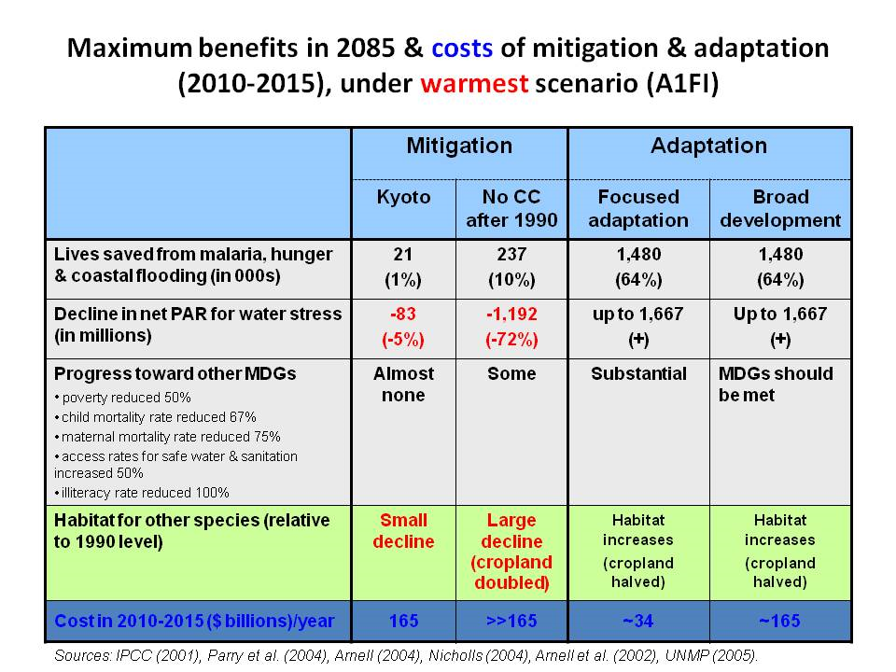
The table shows that through the foreseeable future, vulnerability reduction will provide far greater benefits than even the deepest mitigation, and at a lower cost. And these conclusions hold regardless of the choice of discount rate, or fanciful scenarios beyond the foreseeable future.
Some have argued for mitigation as an insurance policy. Although mitigation (and R&D to expand mitigation options) makes sense so long as its implementation is neither mandatory nor subsidized, reducing vulnerability to current climate-sensitive problems and enhancing adaptive capacity is a far superior insurance policy. It will, unlike mitigation, pay handsome dividends now and in the future, whether or not the climate changes, or in whichever direction it does change. It will reduce risks faster, more effectively, more surely, and by a greater amount. No less important, it would provide the world the wherewithal to deal with a much wider array of future problems, whether they are related to climate or not. In short, vulnerability reduction allows us to solve the urgent problems facing today’s generations and improve their well-being while providing the best hedge for future generations as well.
So, to summarize:the EU is a leader in matters related to climate change. Unfortunately, like the lead lemming, it’s headed in the wrong direction. It has emphasized the wrong policies to address climate change. True leadership requires that not only one head the procession and convince others to follow, but that one also take the correct path. For that, the EU needs to develop policies based on rational analysis rather than feel-good gestures that might backfire.

Indur M. Goklany has worked with federal and state governments, think tanks and the private sector for over 30 years, and written extensively on globalization and environmental issues including sustainable development, technological change, food and health. He has represented the United States at the Intergovernmental Panel on Climate Change and in the negotiations that established the United Nations Framework Convention on Climate Change. He was chief of the Technical Assessment Division of the National Commission on Air Quality and a consultant to the Environmental Protection Agency’s Office of Policy, Planning, and Evaluation. He is the author of The Precautionary Principle and Clearing the Air: The Real Story of the War on Air Pollution.

Fouillet, A., et al. 2008. Has the impact of heat waves on mortality changed in France since the European heat wave of summer 2003? A study of the 2006 heat wave. International Journal of Epidemiology 37(2):309-317, available at http://www.medscape.com/viewarticle/574677_print (registration required).

