Child Migration: Challenging Common Misperceptions

By Giulia Frontini
To what extent does the economic status of the child migrant and their household affect their decision to migrate? Analyze the idea of child agency and how it affects migration-related decisions.
Abstract
Despite the vast literature on child abduction and trafficking, little attention has been paid to independent child migration. This essay analyses the question of child migrants and the extent to which children’s economic status has an influence on their decision to migrate. A number of studies demonstrate that children often move due to poverty related reasons, highlighting the role of children as income earners in the family nucleus. Drawing from these findings we refute the concept of children as beings without agency and show how, through their role in the decision-making process surrounding migration, they play an important role in intergenerational relations.

- Introduction
Despite extensive specialist literature surrounding involuntary child migrants, such as refugees fleeing from violence and conflict or trafficked children (Whitehead, 2005, p.18) little is known about child labour migrants - said to belong to the category of ‘invisible workers’ for they are often ‘hidden, dispersed and ignored’ (Black as cited by Camacho, 1999, p.58; Grugel et al., 2007, p.87). In fact, and up to now, migration studies have mainly been focused on adults (Hosegood, 2003, p.1; Kwankye, 2009), and the migration of children accompanied by family members (Hosegood, 2003; Edmonds, 2007). Yet, and despite the lack of data, we know from recent UNICEF statistics that developing countries host a higher proportion of migrants younger than 20 years old than developed countries and that increasingly more children are deciding to migrate (UNICEF, 2009; Grugel et al., 2007, p.95).
Thus, this paper intends to make a contribution to the budding debate on child migration by seeking to analyze those economic factors influencing children’s relocation, and by assessing to what extent poverty is a deciding element. Likewise, the paper will challenge the prevailing notion of children as beings without agency and as sole victims of trafficking and coercion. When speaking of independent child migrants we refer to children or young people, up to the age of eighteen, who migrate without their parents or other adults. Yet, and although migration can take place amongst young children, it is important to note that evidence suggests that child migrants are found within older age groups, with the proportions increasing rapidly over 12, 14 and 16 years of age (UNICEF, 2007, p.8). In other words, although there are younger children who decide to migrate on their own the majority tend to be ‘adolescents’.
The first part of the essay will analyze those push and pull factors that drive many youths and children to migrate, drawing a link between poverty and migration as a coping strategy for vulnerable and impoverished households. The second part will discuss the concepts of childhood, child agency, and how these dictate our perceptions of the role of the child in intra-family relations and in the decision-making process revolving around migration. The paper will draw from the findings of a number of micro-studies on child migration undertaken in various developing contexts.
However, and as previously mentioned, the literature surrounding the issue is fairly new and incomplete (Workshop on Independent child migration, 2007); this is in part due to the difficulty of gathering data (Camacho, 1999; Hashim, 2005), the paucity and poor quality of the data sources, the lack of a standardized methodology in collecting information and, finally, the illegal and undocumented nature of children’s movements (Whitehead, 2005, p.2). Furthermore, it is important to note that gaps also exist between children’s own perception of their migration experiences and the way that these are often depicted by the media, public opinion, and third parties. With these caveats in mind we now turn to the analysis of the economic reasons for independent child migration.
- Economic Reasons for independent child migration
Children migrate for a number of varied reasons. Findings from Thorsen (2007, p.23), Punch (2007) and Kwankye (2009) have found that this is often seen as a rite of passage: the transition from childhood to adulthood. The recruitment of children by distant relatives for village and housework, known as fostering, is a long-standing tradition in West Africa, and very widespread (Whitehead, 2008, p. 12; Kielland; Thorsen, 2007, p.5). The movement of individuals away from one household to another is a means by which the sending household redresses the balance of demands on scant resources and diversifies potential sources of income, or, alternatively, the means by which a labour-deficient household acquires labour (Hashim, 2005, p.28). Another relevant, and often overlooked, push factor to child migration, is peers’ influence on youths who act both as a major source of information about the destination areas and as a form of aspiration (Kwankye, 2009, p.21; Thorsen, 2007, p.17; Iversen, 2006). Children also migrate for educational purposes. Conflict is yet another reason for migration as illustrated by the Dagbon conflict in Northern Ghana that has contributed, since early 2002, to child migration to the southern part of the country (Kwankye, 2009, p.10).
But how is poverty linked to the decision of independent child migration? For one, rural poverty, or the perception of poverty by the children in question, is a main driver of child labour, and consequently of child migration. In many communities children are encouraged and expected from a very young age to contribute to the household’s livelihood activities (Whitehead, 2007, p.20). This is often compounded by the household’s poverty and the inability of parents to take care of their children. As Camacho (1999, p.64) writes: ‘several authors have argued that migration and child labour are two of the several strategic responses of the family for survival and social mobility’. In the research on independent child migration from northern Ghana, it was found that poverty was in almost 50 percent of the cases stated as the principal reason for boys to leave; and 33 percent in the case of girls (Kielland, p.21). Thus, migration offers to the household the opportunity of an extra income, and possibly, of learning a new trade.
Secondly, and closely linked to the issue of poverty, the lack of general opportunities at home drives children and youths to seek work opportunities elsewhere. For children and young people in rural subsistence communities where work is often limited, lack of opportunities might push children to migrate and seek employment elsewhere (Punch, 2007, p.3). Here, the discrepancy in wages between rural and urban areas plays an important role, as children are more likely to migrate from communities with lower wages (Edmonds, 2007, p.20-21). This is the case in Ghana, where the South’s economic dynamism is often perceived as a ‘pull’ factor (Kwankye, 2009, p. 5; Kwankye, 2007, p.20) attracting children and adults alike to seek jobs in major cities. Similarly, in Camacho’s study (1999, p.66) the higher wages in Metro Manila were the most commonly mentioned reasons for migrating. These financial incentives might go hand in hand with an overarching desire to overcome poverty through self-improvement, as the case of child migration from rural to urban Peru highlights (Leinaweaver, 2008).
At times, child migration becomes a coping strategy to the death or illness of a family member; whether due to HIV/AIDS or other diseases. Hosegood (2003, p.16), Kielland (p.28) and a Report by Save the Children (2007, p.3) find that child migration is strongly correlated to parental mortality. Case in point, and according to Hosegood’s findings, households that experienced the AIDS death of an adult member in 2000 were nearly three times more likely to have dissolved by the end of the year than other households (Hosegood, 2003, p. 18-19). Migration is perceived as a household strategy, aimed at meeting children's needs where this is not possible within the existing household. Therefore, in order to secure a livelihood the child may have to travel either to earn money to cover the health expenses of a family member or for better medical treatment for themselves (Hashim, 2005, p.13). Although sickness or death of a parent or other caregiver is the root cause of child migration, the immediate trigger is generally of an economic nature (Ansell, 2007, p.4). It goes without saying that HIV/AIDS affected households are often very vulnerable to shocks, and as a consequence, more prone to poverty.
The desire to contribute to the income of the family often continues after the child migrates. In fact, as demonstrated by a number of studies (Kwankye, 2009, p.28; Whitehead, 2007, p.34; Camacho, 1999), many send remittances back home as a poverty alleviation strategy (DFID, 2007, p.13). Two-fifths of the children in Camacho’s study (1999, p.67) remitted half or more of their salary to their families, both on a regular and irregular basis. In the case of Lao PDR, 29 percent of the 10-14 year old age group and 45 percent of the 15-17 year old group that was studied sent remittances home (Workshop on independent child migration, 2007, p.28) as did 36 percent of the children in Whitehead’s Bangladesh study (2007, p.34). Alternatively, if remittances are not sent home, on the child’s return to their home village they might bring food or other goods (Hashim, 2005, p. 21).
Thus children migrate for a variety of reasons; as Kwankye summarizes:
‘households can make migration decisions to maximize income flows, or to develop the human capital of some of their members. In other cases, migration can be a response to severe hardship during periods of deprivation and economic stress’ (Kwankye, 2009, p.4).

These motivations, while revolving around the needs of the child worker, should also be considered as contributing indirectly to the family income, which would otherwise have to provide for the children’s education and other needs. In fact many of the children feel that they are helping their family just by being one less mouth to feed (Camacho, 1999, p.65). Despite a tendency to undervalue the economic contribution of children to the household (Camacho, 1999, p.67): ‘the child is considered as a member of the unit of production and consumption’ (Bey, 2003, p.287).

- Children as Agents of Migration
Decision about child labour supply and migration are typically assumed to be made by parents, or to ‘mirror overall household interests in a unitary model of household behaviour’ (Iversen, 2002, p.817). For some, children’s inability to make decision is due to the fact that they lack the ‘cognitive, moral and affective capacities of adults’ (Satz, p.299). However, and as we have seen, children are often active economic members of the household. We therefore now turn to consider the roles of childhood and child’s agency both in the decision making-process of migration and in the household’s intergenerational contract.
  - Notions of Childhood and Agency
“Irrespective of what they do and what they think about what they do, the mere fact of their being children sets children ideologically apart as a category of people excluded from the production of value. The dissociation of childhood from the performance of valued work as been increasingly considered a yardstick of modernity… the problem with this way of defining the ideal of childhood, hover, is that it denies children’s agency in the creation and negotiation of value” (Nieuwenhuys as Cited by Whitehead, 2007, p.40)

For one, and as the quote seems to suggest, it is important to note that Western views of children’s role in society are at great odds with the reality of many developing countries where children are seen as active players in the global political economy. The Western imposed notion of childhood, as an idyllic and protected space, one ideally outside the realm of the market is ‘unrecognizable to the vast majority of children around the world’ (Watson, 2009, p.86; Hashim, 2005, p.34; Horton, p.940; Grugel et al., 2007). Social categories such as ‘children’, ‘adolescents’, and ‘youths’ are historical and cultural constructions formulated by more developed countries (Thorsen, 2007, p.16). The Western discourse stressing parents’ duty to keep children from working, or from undertaking risky processes such as that of migration, is not reflective of the social and economic norms of many developing countries (Thorsen, 2007, p.15). Furthermore, the labeling of children as all those under the age of 18, a definition employed by many bilateral organizations, and by treaties such as the UN Convention on the Rights of the Child, obscures the enormous diversity of the age range 0-18 (Watson, 2009, p.4).
Age is not only relevant when speaking of childhood but also when it comes to discussing children’s agency, for the latter’s decision to migrate is greatly dictated by a child’s maturity and age (Bushin, 2009, p.436). Agency refers not to the intentions people have in doing things but to their capability of doing those things in the first place. As is clear from the Oxford English Dictionary definition of an agent: ‘one who exerts power or produces an effect’, agency implies power (Cassell as cited by Hess, p.770). Children, as active participants in the labour force, and similarly to adults, have objectives, responsibilities, interests and agency. Consequently, by considering children’s views and understandings of their own responsibilities within a household we can better understand the role of children’s agency. As a study conducted on child domestic work in Manila shows:
“Most of the children stated they wanted to help their parents and their siblings…in their families’ precarious conditions, they perceived that, as dutiful children, it was imperative for them to work and contribute to the family income” (Camacho, 1999, p.65).

However, the movement of children is not merely a livelihood strategies at the household level, but also at the level of the individual child (Punch, 2007, p.4). As children become older (and reach the age of 14) they themselves begin to adopt their own livelihood strategies and start to seek their own welfare-maximizing opportunities. To achieve their own economic, social and educational objectives, migration presents itself as the bet strategy to do so (Whitehead, 2007, p.19). For some, this might entail choosing to live in a different location to secure a different kind of patron, obtaining a training opportunity or earning the income needed to purchase the items necessary for progression into adulthood or marriage. Case in point, findings from Iversen’s study (2002) on rural Karnataka show that child labour migrants’ decision to migrate conforms to a definition of strong child autonomy. This is not to suggest that children, especially those of a young age, are conscious or aware of the consequences of migration: and there of course exist constraints on the child’s ability or capability to exercise of his or her own agency (Whitehead, 2007, p.42).
  - Intergenerational contracts
Having established that children do have an agency we now turn to the greater debate of children’s role within the family nucleus and of the so-called inter-generational contract. This refers to the relationship between child and parent, and to the shared understandings between family members ‘as to what each owes and can expect from other within the family’ (Whitehead, 2007, p.5). Albeit the conceptual language used to explore parent-child relations remains to be fully developed the idea of a ‘contract’ is used to highlight ‘the fact that a great deal of interaction within the family is not random, … but rather governed by norms and customs which make up the social meaning of the family in that context’ (Whitehead, 2007, p.15). It is through these implicit contracts, drawn in the arenas of households, in which both children and adults exercise agency and their own decision-making skills (Thorsen, 2007, p.22).
Yet, how does migration affect the values embodied in the intergenerational contract? Interestingly and erroneously, child migration has often been associated with family dysfunction, or the breaking down of the family nucleus (Whitehead, 2007, p.7). On the contrary, migration decisions often highlight the unity of the family for the household is ‘a coalition vis-à-vis the rest of the world [where] family members share costs and rewards of migration’ (de Hann et al., 2007, p3). Furthermore, adolescents who migrate are often active participants in the decision making progress, for they see migration as an asset diversificator and income generator. However, important to keep in mind are the varying degrees of children’s participation in the decision to migrate, as presented by Figure 1 (Bushin, 2009, p.432).
This is not to say that children act as the sole actors in the decision making process, rather that they should be seen as active participants within the household and, unlike the 2000 Trafficking Protocol, stating that children’s consent is irrelevant, they often do have a voice and opinion on the matter. Family decisions surrounding migration are not only complex but also multilayered, with no static balance when it comes to decision-making power (Bushin, 2009, p.439). Therefore, children should neither be depicted as ‘romantic heroes’ or ‘passive victims’ (Workshop on independent child migration, 2007, p.6). Similarly to the gender discourse, there needs to be a reexamination of the differences between adults and children, and the nature and construction of this relationship. As Erica Burman argues: ‘discourses of childhood are central to definitions of adulthood: each relies upon and secures the boundaries of the other’ (Watson, 2009, p.3).
Figure 1. Children and Migration Decision-Making
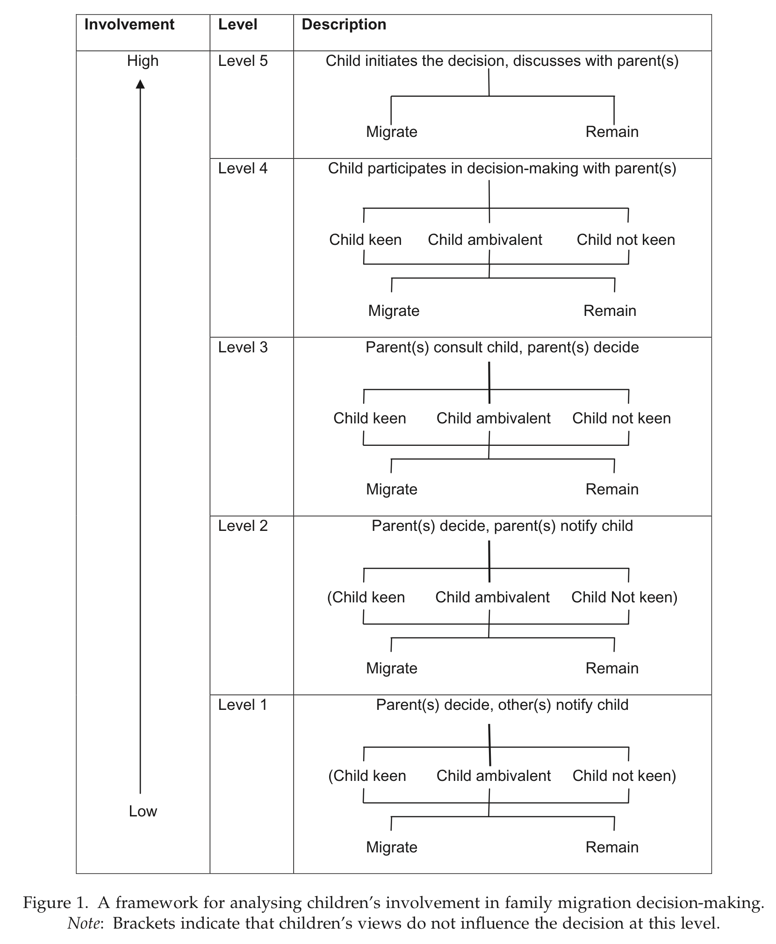
Source: Bushin, 2009, p.433
- Conclusion
This essay has attempted to highlight some of the complexities that surround independent child migration. As the evidence presented shows: ‘migration can help individuals and their families to increase their income, learn new skills, improve their social status, build up assets and improve their quality of life’ (DFID, 2007, p.2). In other words, a central motivation for children to migrate, that has been generally underplayed, is their need or desire for income. As many come from rural economies, in which children start earning their own independent incomes quite early on, it is not surprising that some would resort to migration to find labour or as a means to contribute to family earnings. In addition, children may be encouraged to migrate to meet their own consumption needs, and buy items such as clothes or food. Alternatively, they might migrate in order to provide for sick family members, or to lessen the burden of their families. Thus, children’s choice to leave must be situated in an economic and social context: where poverty and limited opportunities at home, as well certain responsibilities within the household, drive youths to seek work elsewhere (Workshop on Independent Child Migration, 2007; Kwankye, 2007, p.2).
The invisibility of independent child migrants has been compounded by contemporary constructions of childhood. As shown, these have magnified children’s invisibility in the international political economy, often leading to the misconstruction of the concept of child agency. The adoption of a Western lens to analyze issues of childhood is inappropriate for it fails to distinguish between the different needs, capabilities and preferences of 0-18 year olds. As a result, when speaking of intergenerational relations one needs to consider the role of the child in the decision to migrate as adults are not always the sole decision-makers.
Nevertheless, however voluntary and whatever the economical reasons driving child migration, there is a pressing need for policy makers to revisit current understandings of independent child migration: for at present few organizations and government agencies have tried to reach out to migrant children (Save the Children, 2001, p.9; Grugel, 2007, p.96). In the long run the failure to do so could lead to the intensifying of child’s poverty, vulnerability and isolation.

Bibliography

- Ansell, N., & Young, L. (2007). Young AIDS Migrants in Southern Africa. DFID.
- Bey, M. (2003). The Mexican Child: From Work with the Family to Paid Employment. Childhood , 10 (3), 287-299.
- Bushin, N. (2009). Researching Family Migration Decision-Making: A Children-in-Families Approach. Population, Space and Place , 15, 429-443.
- Camacho, A. (1999). Family, Child Labour and Migration: Child domestic workers in Metro Manila. Childhood , 6 (1), 57-73.
- de Hann, A., & Yaqub, S. (2007). Migration and Poverty: Linkages, Knowledge Gaps and Policy Implications. Social Policy and Migration in Developing Countries. Stockholm.
- DFID. (2007). Moving out of Poverty - Making Migration Work Better for Poor People.
- Edmonds, E. V., & Salinger, P. (2007). Economic Influences on Child Migration Decisions: Evidence from Bihar and Uttar Pradesh. IZA , 3174, 1-45.
- Grugel, J. (2007). Critical Perspectives on Global Governance: Rights and Regulation in Governing Regimes. NY: Routledge.
- Hashim, I. M. (2005). Research Report on Children's Independent Migration from Northeastern to Central Ghana. DRC, Brighton.
- Hashim, I. (2006 йил September). The Positives and Negatives of Children's Independent Migration: Assessing the Evidence and the Debates. 1-35.
- Hess, J. (2008). Kids at the Crossroads: Global Childhood and the State. Anthropoligical Quarterly , 81 (4), 765-776.
- Hosegood, V., & Ford, K. (2003). The Impact of HIV/AIDS on children's living arrangements and migration in rural South Africa. Conference on African Migration in Comparative Perspective, (pp. 1-48). Johannesburg.
- Iversen, V. (2002). Autonomy in Child Labor Migrants. World Development , 30 (5), 817-834.
- Iversen, V. (2006). Segmentation, Network Multipliers and Spillovers: A Theory of Rural Urban Migration for a Traditional Economy. DRC.
- Kielland, A., & Sanogo, I. Burkina Faso: Child Labor Migration from Rural Areas. World Bank.
- Kwankye, S., & Anarfi, J. (2007). Coping Strategies of Indepent Child Migrants from Northern Ghana to Southern Cities. DRC , T-23, 1-27.
- Kwankye, S., & Anarfi, J. (2009 йил February). Independent North-South Child Migration in Ghana: The Decision Making Process. DRC , 1-38.
- Leinaweaver, J. (2008). Improving Oneself: Young People Getting Ahead in the Peruvian Andes. Latin American Perspectives , 35 (4), 60-78.
- Punch, S. (2007). Migration Projects: Children on the Move for Work and Education. Workshop on Independent Child Migrants: Policy Debates and Dilemmas. London: DRC.
- Satz, D. Child Labor: A Normative Perspective. THe World Bank Economic Review , 17 (2), 297-309.
- Save the Children (2001). Breaking Through the Clouds: A Participatory Action Research (PAR) Project with Migrant Children and Youth Along the Borders of China, Myanmar and Thailand. (UK).
- Save the Children. (2007). Children Crossing Borders: Report on unaccompanied minors who have travelled to South Africa. (UK).
- Thorsen, D. (2007). 'If Only I Get Enough Money for a Bycicle!: A Study of Childhoods, Migration and Adolescent Aspirations Against a Backdrop of Exploitation and Trafficking In Burkina Faso. T21, 1-28.
- UNICEF. (2009). Children, Adoloscents and Migration: Filling the Evidence Gap.
- Watson, A. (2009). The Child In International Political Economy. NY: Routledge.
- Whitehad, A., & Sward, J. (2008). Independent Child Migration: Introducing Children's Perspectives. Development Research Centre on Migration, Globalisation & Poverty , 11, 1-4.
- Whitehead, A., & Hashim, I. (2007 йил December). Child Migration, Child Agency and Inter-generational Relations in Africa and South Asia. DRC , 1-46.
- Whitehead, A., & Hashim, I. (2005). Children and Migration: Background Paper for DFID Migration Team.
- Workshop on Independent Child Migrants: Policy Debates and Dilemmas. (2007). London: UNICEF & DRC.

As defined by the Convention on the Rights of the Child.
International data sets dealing with demographic information, such as those provided by UNICEF, the ILO and UNFPA tend not to link the sectors of age and population movement. Similarly, the International Organization of Migration (IOM) does not offer migration statistics on child migration (Grugel et al., 2007, p.95)
In the case of girls from Northern Ghana migration is a mean of becoming more eligible for marriage through the acquisition of basic items such as cutlery and bowls (Kwankye, 2009, p.6; Hashim, 2006)
The practice of fostering is perceived as a benign phenomenon aimed at redistributing the costs and benefits of children. However, according to the UN Protocol to Prevent, Suppress and Punish Trafficking in Persons, Especially Women and Children (often referred to as the Palermo Protocol), child trafficking is defined as the ‘recruitment, transportation, transfer, harbouring or receipt of a child for the purpose of exploitation’ (UN 2001), and an intermediary who gives or receives payments (or expects to give or receive payments) can be considered a child trafficker if there is intent on the part of the intermediary to exploit the child (Hashim, 2005, p.46).
In an example from Ghana, Hashim points out children’s typical chores: from the age of four or five they are expected to help with tasks around the house. These might include caring for their siblings and running errands. Between seven and thirteen, they gradually begin engaging in almost all those tasks that usually fall within adults’ spheres of influence; and, by the age of fourteen, they are carrying out all those tasks that adults of their gender are able and expected to do (Hashim, 2005, p.5).
ILO data suggests that in developing countries a total of 250 million children are engaged in paid work (Grugel et al., 2007, p.91).
Albeit this is a possible outcome of children’s desire to leave, it is not a universal trend.

