Just How Supportive of President Bush is Prime Minister Harper?
By Alicia Zorzetto
Stephen Harper, the newly elected Prime Minister of Canada was applauded, welcomed and viewed in a positive manner by the Bush administration. However, recent "saber rattling" by Harper concerning Canadian sovereignty relative to their arctic islands has raised several concerns within the neo-conservative Bush administration. The national status within septentrional Canada has now become a prominent concern to Harper. Recent climatic changes have provided access to a northern trading route known to many individuals as the Northwest Passage. In comparison to the route through the Panama Canal, the transportation of goods via the northern archipelago of Canada would save a cargo vessel approximately 4000 km from Europe to the Far East. The question regarding international access through this potentially viable trading route, and the sovereignty rights regarding Canadian jurisdiction in the arctic, has established novel points of contention between the Canadian and American governments.
It is important to recognize that the stability of the political relationship between the Canadian and American governments has never been constant. Prime Minister Harper’s stance in support of various decisions made by President Bush is entirely diverse from Canada’s previous Liberal governments that have had a reputation of conflicting with the positions held by the Bush administration. Former Canadian Prime Minister, Jean Chrétien commented in a CBC interview that the 9/11 terrorist attacks were a cause of America’s own “wealth, greed, and power”.¹ He later added in a speech to the United Nations that 9/11 is “the tragic consequence that can result from failed states in far-away places”.² In addition, Liberal Member of Parliament Carolyn Parish commented, “Americans! I hate the bastards!” She subsequently referred to Bush’s allies Iraqi war as a “coalition of the idiots”.³
Prime Minister Harper, as former Conservative “Leader of the Opposition” during the Liberal governments of Jean Chrétien and most recently Paul Martin, had repeatedly supported the Bush administration relative to US foreign policy. This support included the American pre-emptive air strikes and subsequent invasion of Iraq and the most recent North American missile defense shield initiative. Both of these issues were vehemently opposed by the ruling Liberal governments. These foreign policy conflicts between the US and the Liberal Canadian government impacted other trade related issues such as the “mad cow” and softwood lumber disputes. Obviously, the Bush administration did not embrace the Canadian Liberal prime ministers. In fact, the former US ambassador to Canada, Paul Cellucci, was most outspoken in his opposition to Liberal policy positions. In a speech to the Economic Club of Toronto, Cellucci affirmed that “we [Bush Administration] are disappointed that some of our closest allies, including Canada, have not agreed with us on the urgent need for this military action against Iraq”.⁴
Consequently, the recent election of Stephen Harper, as Canadian prime minister, was well received by the Bush administration. Although popular opinions within Canada had typically been to support the decision of not joining the war in Iraq, Harper’s stance, on what was perhaps the most divisive issue regarding current Canadian-U.S. relations, was expected to encourage further cooperation between the two countries. Michael Wilson, the newly appointed Canadian ambassador to America, told The Globe and Mail that Canada should have joined the war in Iraq by offering ships, aircraft and moral support.⁵ Harper is also supportive of other internal Bush initiatives relative to various moral issues such as the opposition to gay marriage and abortion - subjects that were accepted by an extremely liberal Canadian government.
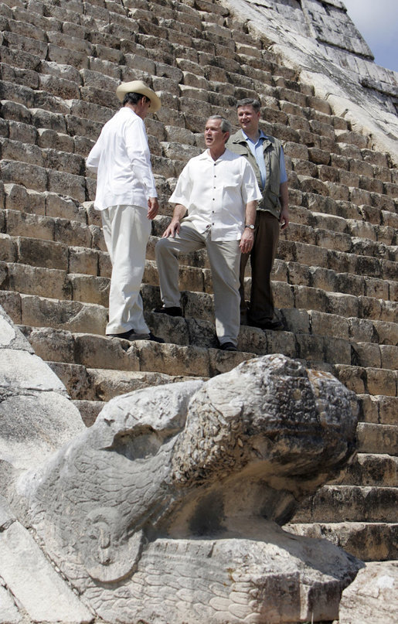
Harper’s electoral victory over former Prime Minister Paul Martin generated a perception in Washington that future U.S.-Canadian relations would be enhanced. An amicable association between Harper and Bush seemed apparent after U.S. President George Bush called Prime Minster Harper to personally extend his congratulations

Copyright; the United State Federal Government
concerning the Conservative victory in Canada. President Bush “looks forward to working with him” (Harper), said White House spokesman, Scott McClellan.⁶ It is interesting to note that former Liberal prime ministers, Chrétien and Martin, were never invited to the Bush ranch in Crawford, Texas or the White House in Washington, D.C. Nor did either former PM ever have the opportunity to enjoy a morning stroll with President George W. Bush, and Mexican President Vicente Fox on the Chichen-Itza Archaeological Ruins.
Yet, after Harper’s unyielding stance regarding Canadian autonomy of their arctic archipelago, conflict between the two nations contains a measure of probability. In the last three decades, climatic changes have caused a 25 percent reduction in the area covered by Arctic sea-ice - a decline of approximately 2,000,000 square kilometers!⁷ The melting ice will not only open the Northwest Passage but will also amplify access to natural gas/oil reserves, and various sea bed minerals within this northern region. Thus, it is no wonder that America, along with the quiet support of many other interested nations, has considerable interest in this area. Current US ambassador to Canada David Wilkins, recently stated that “We [the United States] don’t recognize Canada’s claims to those waters”.⁸ Former executive Secretary Theodore L. Eliot, affirmed that the United States should not accept the Canadian assertion that the Northwest Passage are internal Canadian waters. “Such acceptance would jeopardize the freedom of navigation essential for United States naval activities worldwide, and would be contrary to our fundamental position that the regime of the high seas can be altered only by multilateral agreement” .⁹

Even though the Canadian government is opposing the American hegemony, and has little international support in its position concerning this northern trade route, its argument should not be perceived as unfeasible. Harper declared in December, 2005 “We simply need to know when the ships of the United States, Russia or any other country are in Canadian waters, and we will require them to ask our consent to traverse our waters”.¹⁰ Harper’s military shopping list, to ensure Canadian sovereignty in the arctic, will include underwater sensors to track submarines, the upgrading of air surveillance measures, new ice-breaking frigates equipped with modern helicopters, several rapidly deployable airborne battalions and the creation of a deep water, military base at Iqaluit on Baffin Island. Prime Minister Harper has clearly chosen to defend Canadian outposts with regards to the Northwest Passage, rather than allying with newly established American associates.
Map of Northwest Passage ¹¹
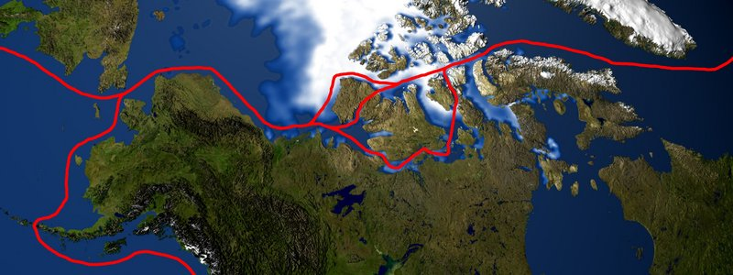
Regardless of whether the route is viewed as Canadian territory or international waters, the opening of the Northwest Passage will provide Canada with economic and social benefits. Commerce through this region will produce financially viable benefits with the establishment of ports, the search for minerals and plausible increases in tourism thus assisting one of Canada’s most impoverished regions. It is also a novel approach to enhancing international knowledge of northern Canadian culture, specifically the culture of Canadian aboriginals – the Inuit. Furthermore, the Canadian national government is not prohibiting the international shipment of goods through the territory. Instead, they are demanding the right to establish clear regulations, and a mandatory reporting system to protect a considerably fragile eco-system, and ultimately Canadian sovereignty. “As Prime Minister, I will make it plain to foreign governments - including the United States - that naval vessels traveling in Canadian waters will require the consent of the government of Canada” stated Harper.¹² Thus, it is not as if Prime Minister Harper is attempting to ban international travel through the Northwest Passage, he is merely requesting that the ships abide by Canadian, rather than international guidelines.
A significant issue stemming from this dispute concerns Canada’s future within the international community. Canada has routinely been recognized for its efforts to remain a peaceful, tolerant nation. Former Canadian Governor General of Canada, Adrienne Clarkson affirmed that “Canada is known and honoured as a steadfast and skilful advocate for international collaboration, reconciliation, and the promotion of peace”.¹³ Yet, Prime Minister Harper plans to budget an additional $5.3 billion over a five year period to augment defense spending, especially the arctic region. The increase in defense spending may have a noteworthy impact on various Canadian foreign aid expenditures, including the Canadian commitment to assist poor countries in the elimination of their foreign debt.
Will Canada continue as a “skilful advocate for the promotion of peace”? Will Harper be able to reconcile his differences with Bush regarding the Northwest Passage? Will there be a warning “shot across the bow”?
The melting polar ice cap is slowly brewing a tempest.

End Notes
¹“PM slammed, defended for 9/11 remarks, 1-2. (2002)
² "Canada PM Criticises 'arrogant' West." 1-2. (2002)

³ Jackson, Paul. "Canada's Foreign Policy Turning Pro-American." (2006)

⁴ Cellucci, Paul. “Cellucci’s Statement” (2003)
⁵ Curry, Bill, and Paul Koring. "New envoy Wilson backed Bush on Iraq." (2006)
⁶ “Bush calls Harper to Congratulate Him on Win." (2006)
⁷ Byers, Micheal. “The Need to Defend our new Northwest Passage”. (2006)
⁸ Wilkins, David. “Canada’s New Leader takes on US over Arctic”. (2006)
⁹ “Foreign Relations” 1969-1976, Volume E-I, Documents on Global Issues
¹⁰ Harper, Stephen. "Harper Stands Up for Arctic Sovereignty." (2005)
¹¹ NASA, dwindling arctic sea Ice (http://en.wikipedia.org/wiki/Image:Northwest_passage.jpg#filelinks) (2006)
¹²idbid. Harper
¹³ Clarckson, Adrienne. "Her Excellency the Right Honourable Adrienne Clarkson." (2004)

Works Cited
"Bush calls Harper to Congratulate Him on Win." CTV News 26 Jan. 2006. Available at <<http://www.ctv.ca/servlet/ArticleNews/story/CTVNews/20060125/elxn_aftermath_wrap_060125?s_name=&no_ads=>>.
Byers, Micheal. “The Need to Defend our new Northwest Passage”. The Tyee. 30 Jan. 2006. Available at <<http://thetyee.ca/Views/2006/01/30/DefendNorthwestPassage/>>.
“Canada’s New Leader takes on US over Arctic”. MSNBC News January 27, 2006. Available at << http://www.msnbc.msn.com/id/11057794/>>.
"Canada PM Criticises 'arrogant' West." BBC News 13 Sept. 2002. Available at
<<http://news.bbc.co.uk/1/hi/world/americas/2254761.stm>>.
Cellucci, Paul. Speech to the Economic Club of Toronto. March 25, 2003. Available at <<http://www.ourrant.ca/members/drgonzo/PDFs/cellucci_speech.pdf>>.
Clarckson, Adrienne. "Her Excellency the Right Honourable Adrienne Clarkson." Rideau Hall. 29 Nov. 2004. Available at <<http://www.gg.ca/media/doc.asp?lang=e&DocID=4323>>.
Curry, Bill, and Paul Koring. "New envoy Wilson backed Bush on Iraq." Globe and Mail 16 Feb. 2006. Bell Globemedia Publishing Inc. 17 Feb. 2006.
“Foreign Relations” US Department of State. Volume E-I, Documents on Global Issues, 1969-1972. Available at << http://www.state.gov/r/pa/ho/frus/nixon/e1/53180.htm>>.
Harper, Stephen. "Harper Stands Up for Arctic Sovereignty." Ottawa. 22 Dec. 2005. Available at <<http://www.conservative.ca/media/20051222-Speech-Harper-Winnipeg.pdf>>.
Hewitt, Kimberlee. Photo of President George W. Bush stands with President Vicente Fox of Mexico, left, and Canada's Prime Minister Stephen Harper. United States Federal Government. Available at: <<http://www.whitehouse.gov/news/releases/2006/03/images/20060330-2_p033006kh-0465-807v.html>>.
Jackson, Paul. "Canada's Foreign Policy Turning Pro-American." The American Thinker 17 Feb. 2006. Keyword: Carolyn Parish. Available at
<<http://www.americanthinker.com/articles.php?article_id=5256>>.
Mitchell, Alanna. "The Northwest Passage Thawed." The Globe and Mail (2005). 18 Jan. 2005 <<http://www.carc.org/whatsnew/writings/amitchell.html>>.
"PM slammed, defended for 9/11 remarks." CBC News 13 Sept. 2002. CBC. Available at <<http://www.cbc.ca/story/canada/national/2002/09/12/pm_reax020912.html>>.

